%%%%%%%%%%%%%%%%% 1.image files and Storing %%%%%%%%%

img = imread('window.png');

[BW,threshOut] = edge(img,'Sobel');

window_edge = edge(img,'Canny',threshOut);

subplot(1,2,1), imshow(img),title('Original image');

subplot(1,2,2), imshow(window_edge),title('Edge using Canny');

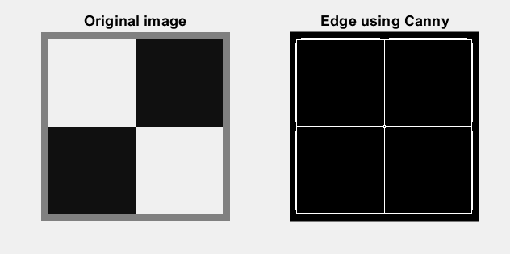

%%%%%%%%%%%%%%%%% 2.Hough Transform %%%%%%%%%%%%%

%a

[H, theta, rho]= hough_lines_votes(window_edge,1,linspace(-90, 89, 180));

[H1,theta1,rho1] = hough(window_edge);

k = H==H1 ; % get the equal elements

iwant = sum(k(:)); % total number of equal elements

percentage = iwant/(723*180)*100;

g= uint8(H);

h= uint8(H1);

subplot(1,2,1), imshow(g),title('My H image');

subplot(1,2,2), imshow(h),title('Using inbuit function');

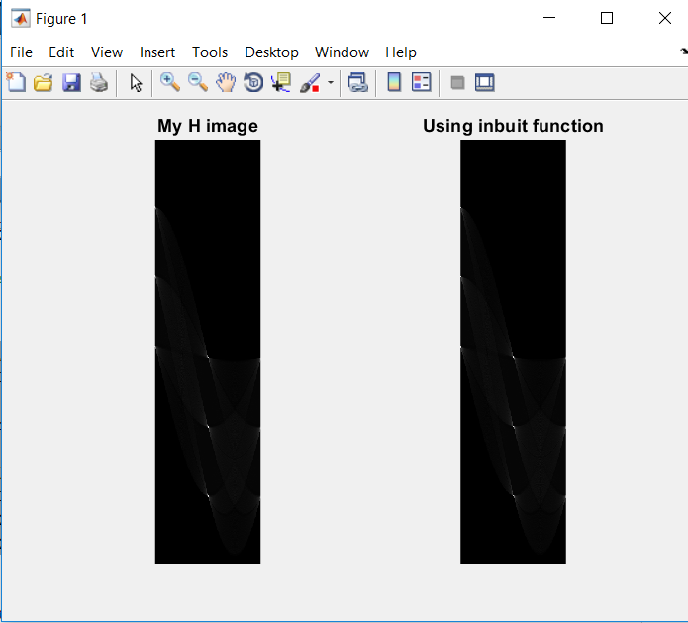

%b

Threshold=0.5 * max(H(:));

NHoodSize= (floor(size(H) / 100.0) * 2 + 1);

peaks = hough_peaks(H,10,Threshold,NHoodSize);

peaks1 = houghpeaks(H,10);

imshow(H,[],'XData',theta,'YData',rho,'InitialMagnification','fit');

xlabel('\theta'), ylabel('\rho');

axis on, axis normal, hold on;

plot(theta(peaks(:,2)),rho(peaks(:,1)),'s','color','white');

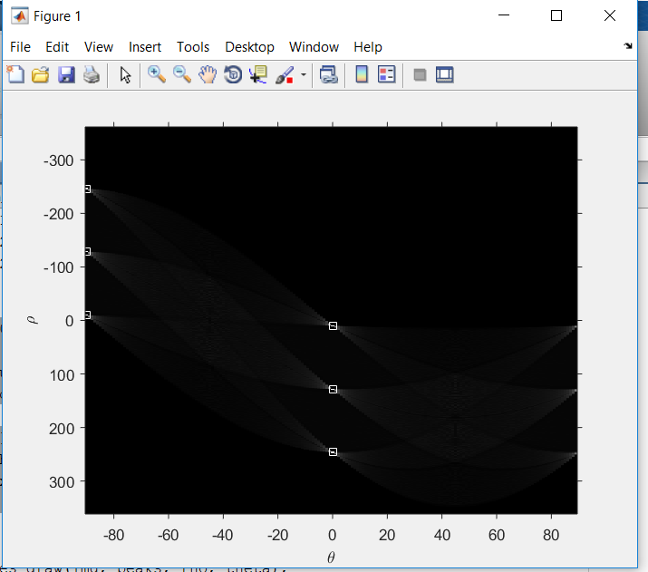

%c

hough_lines_draw(img, peaks, rho, theta);

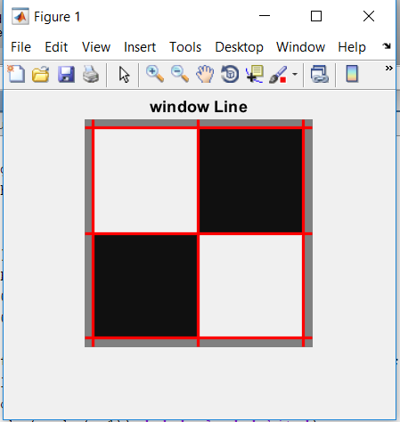

%%%%%%%%%%%%%%%%% 3.Window image with noise %%%%%%%%%%%

%a

img_noise= imread('window_w_noise.png');

Iblur1 = imgaussfilt(img_noise,4);

Iblur2 = imgaussfilt(img_noise,6);

subplot(1,3,1), imshow(img_noise),title('original image');

subplot(1,3,2), imshow(Iblur1),title('Gaussian with sigma 4');

subplot(1,3,3), imshow(Iblur2),title('Gaussian with sigma 6');

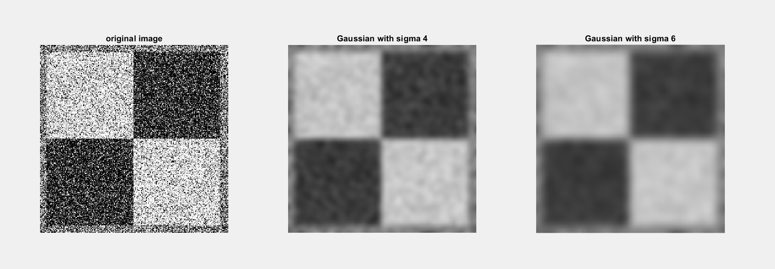

%b

[BW1,threshOut1] = edge(img_noise,'Sobel');

[BW2,threshOut2] = edge(Iblur1,'Sobel');

[BW3,threshOut3] = edge(Iblur2,'Sobel');

window_edge1 = edge(img_noise,'Canny',threshOut1);

window_edge2 = edge(Iblur1,'Canny',threshOut2);

window_edge3 = edge(Iblur2,'Canny',threshOut3);

subplot(1,3,1), imshow(window_edge1),title('original image edge');

subplot(1,3,2), imshow(window_edge2),title('Gaussian with sigma 4 edge');

subplot(1,3,3), imshow(window_edge3),title('Gaussian with sigma 6 edge');

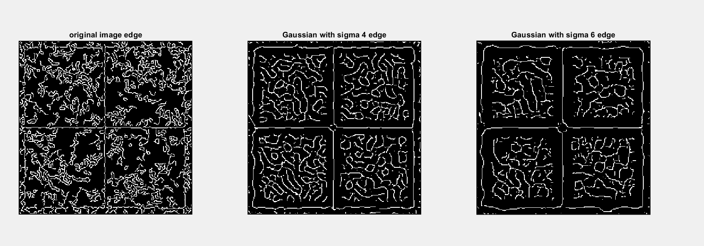

%c

[H3, theta3, rho3]= hough_lines_votes(window_edge3,1,linspace(-90, 89, 180));

[H4,theta4,rho4] = hough(window_edge3);

g1= uint8(H3);

h1= uint8(H4);

subplot(1,2,1), imshow(g1),title('My smoothened H image');

subplot(1,2,2), imshow(h1),title('Smoothened Using inbuit function');

Threshold1=0.5 * max(H3(:));

NHoodSize1= (floor(size(H3) / 100.0) * 2 + 1);

peaks3 = hough_peaks(H3,10,Threshold1,NHoodSize1);

peaks4 = houghpeaks(H3,10);

imshow(H3,[],'XData',theta3,'YData',rho3,'InitialMagnification','fit');

xlabel('\theta'), ylabel('\rho');

axis on, axis normal, hold on;

plot(theta3(peaks3(:,2)),rho3(peaks3(:,1)),'s','color','white');

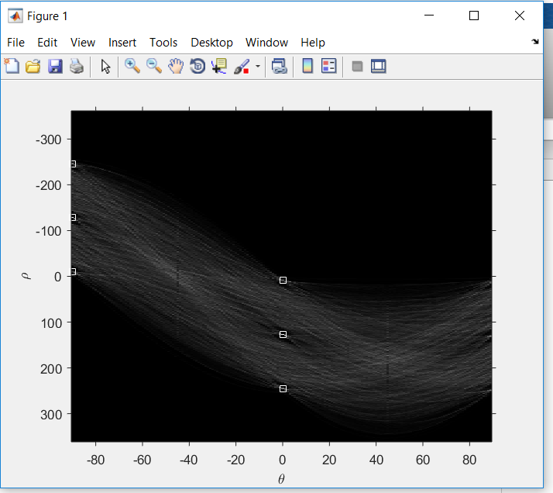

hough_lines_draw(img_noise, peaks3, rho3, theta3);

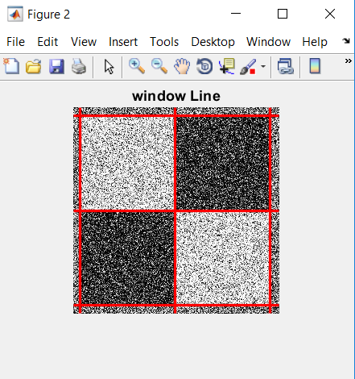

%%%%%%%%%%%%%%%%% 4. Coins and pens %%%%%%%%%%%%%%%%%%%%%%%%%

i = imread('coins_and_pens.png');

j = rgb2gray(i);

blur1 = imgaussfilt(j,4);

blur2 = imgaussfilt(j,6);

subplot(1,3,1), imshow(j),title('original grey scale image');

subplot(1,3,2), imshow(blur1),title('Gaussian with sigma 4');

subplot(1,3,3), imshow(blur2),title('Gaussian with sigma 6');

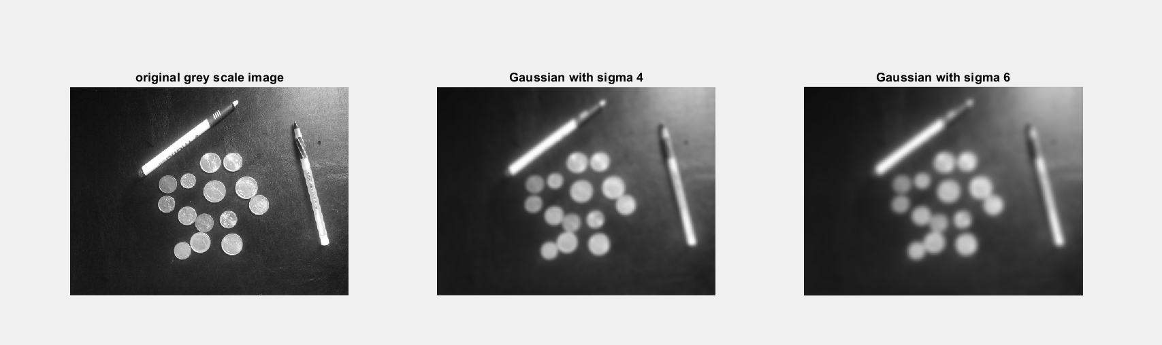

%b

[BW4,threshOut4] = edge(j,'Sobel');

[BW5,threshOut5] = edge(blur1,'Sobel');

[BW6,threshOut6] = edge(blur2,'Sobel');

window_edge4 = edge(j,'Canny',threshOut4);

window_edge5 = edge(blur1,'Canny',threshOut5);

window_edge6 = edge(blur2,'Canny',threshOut6);

subplot(1,3,1), imshow(window_edge4),title('original image edge');

subplot(1,3,2), imshow(window_edge5),title('Gaussian with sigma 4 edge');

subplot(1,3,3), imshow(window_edge6),title('Gaussian with sigma 6 edge');

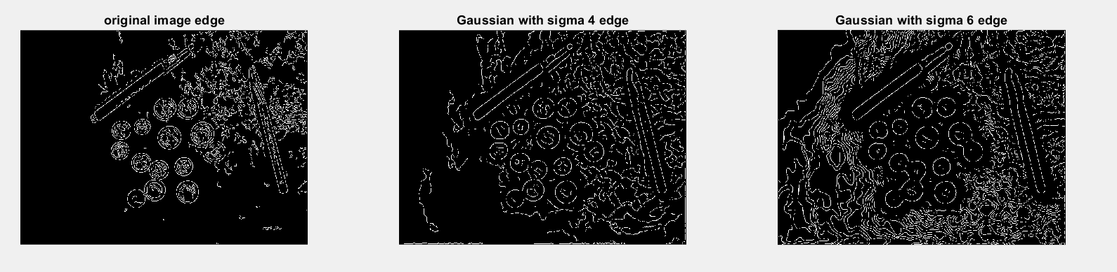

After editing with VARARGIN in matlab: code in Part 2

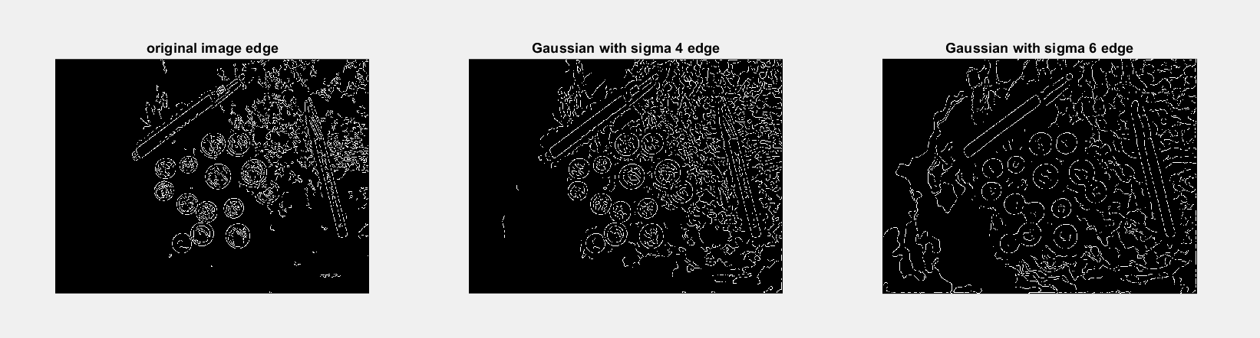

%c

[H5, theta5, rho5]= hough_lines_votes(window_edge6,1,linspace(-90, 89, 180));

[H6,theta6,rho6] = hough(window_edge6);

g2= uint8(H5);

h2= uint8(H6);

subplot(1,2,1), imshow(g2),title('My smoothened H image');

subplot(1,2,2), imshow(h2),title('Smoothened Using inbuit function');

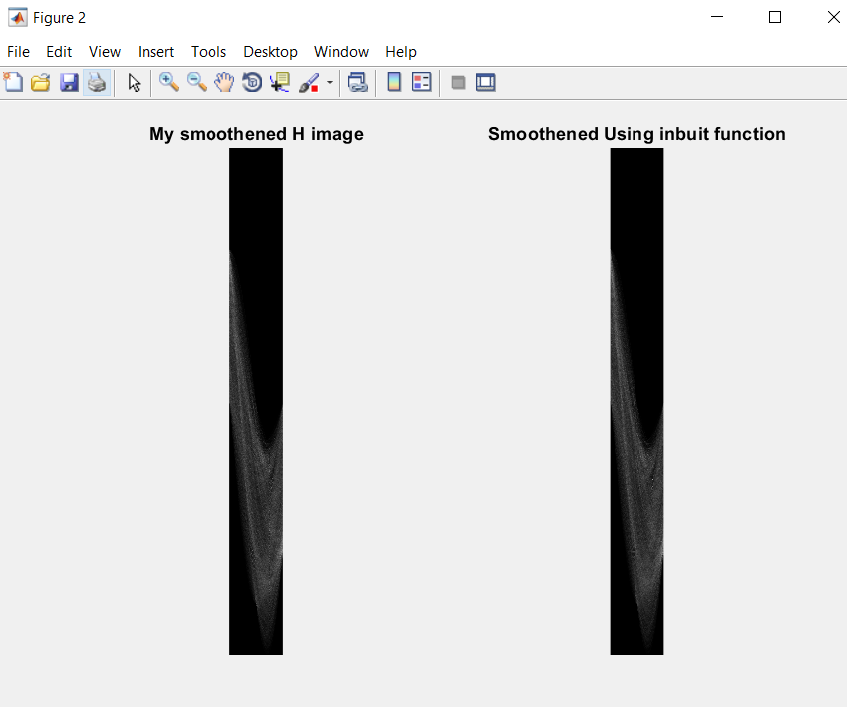

Threshold2=0.5 * max(H6(:));

NHoodSize2= (floor(size(H6) / 100.0) * 2 + 1);

peaks5 = hough_peaks(H6,10,Threshold2,NHoodSize2);

peaks6 = houghpeaks(H6,10);

imshow(H6,[],'XData',theta6,'YData',rho6,'InitialMagnification','fit');

xlabel('\theta'), ylabel('\rho');

axis on, axis normal, hold on;

plot(theta6(peaks6(:,2)),rho6(peaks6(:,1)),'s','color','white');

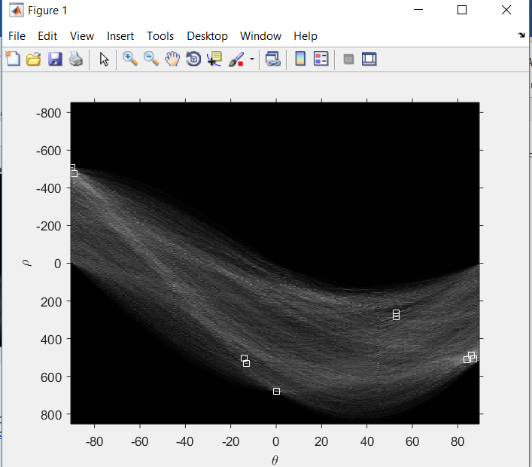

After VARARGIN in part 2:

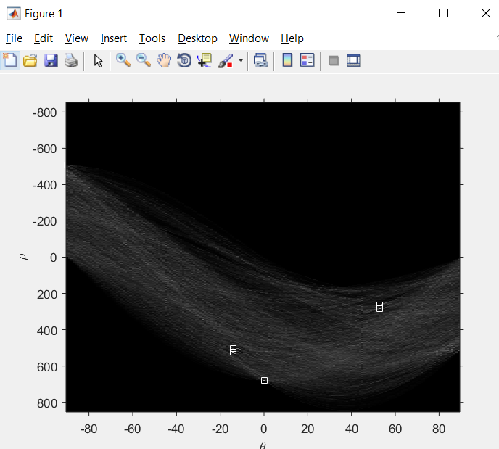

hough_lines_draw(j, peaks6, rho6, theta6);

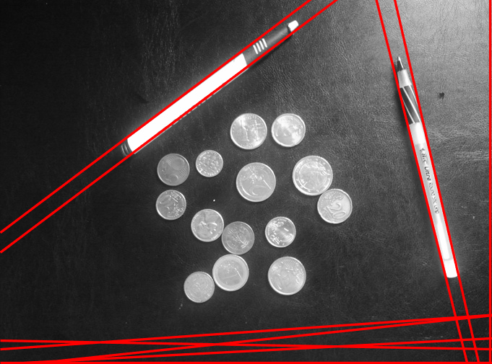

### INCREASING THE SMOOTHENING

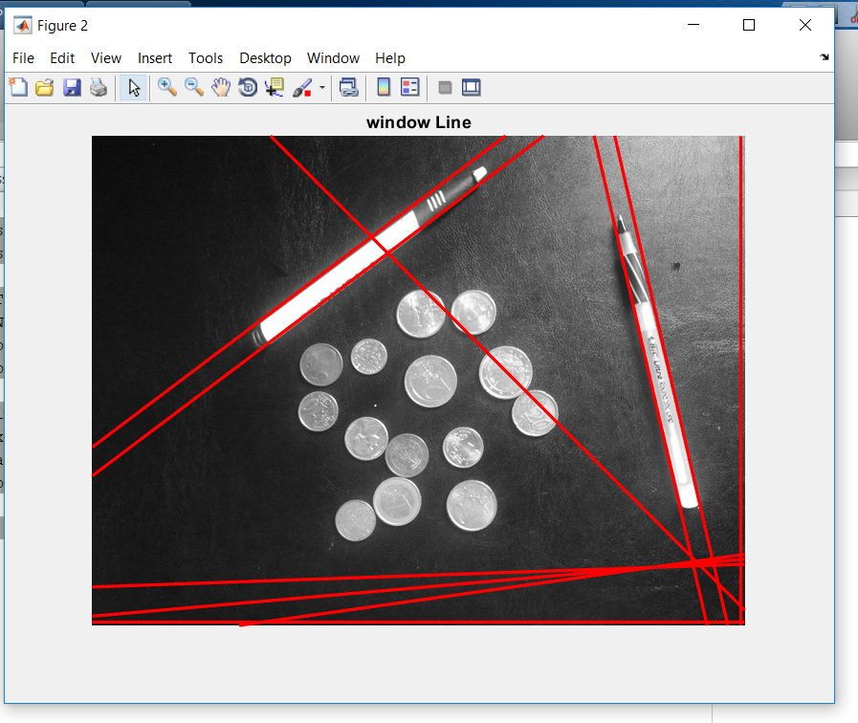

## for sigma 2

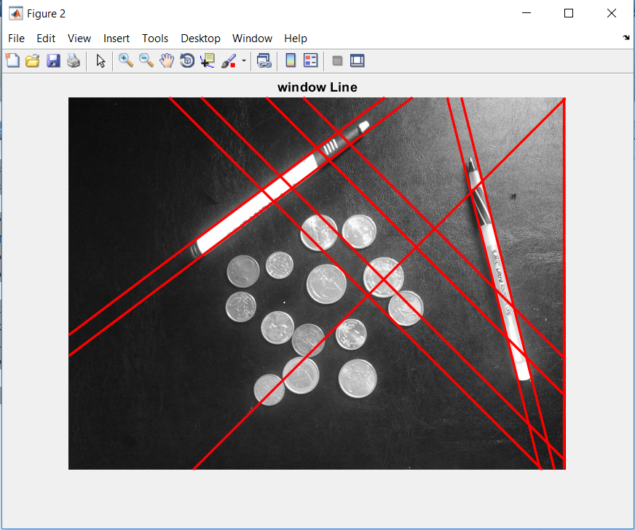

# FOR SIGMA 5

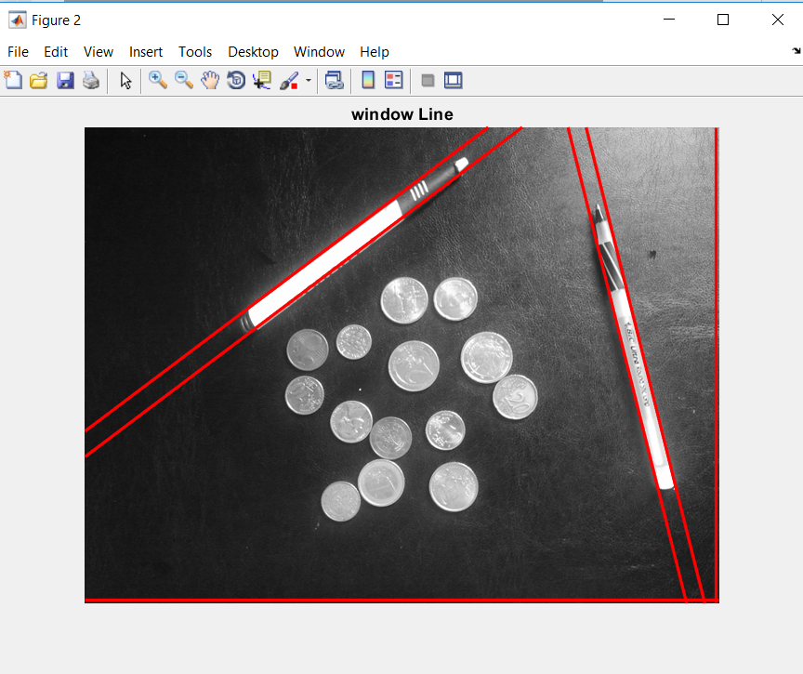

# for sigma 4

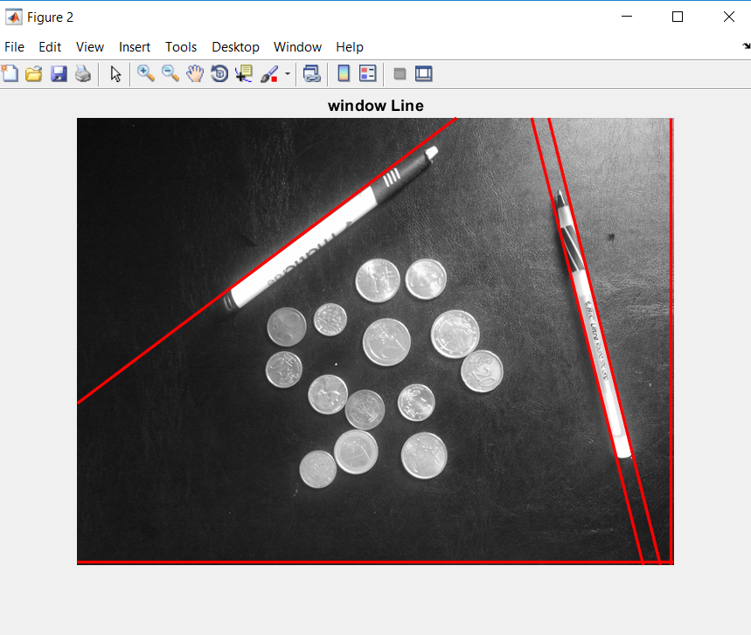

%%%%%%%%%%%%%%%%%% 5. CIRCLES ##########################

radius=20;

H5 = hough_circles_votes(window_edge6, radius);

t1= uint8(H5);

figure(); imshow(t1),title('coins and pens H');

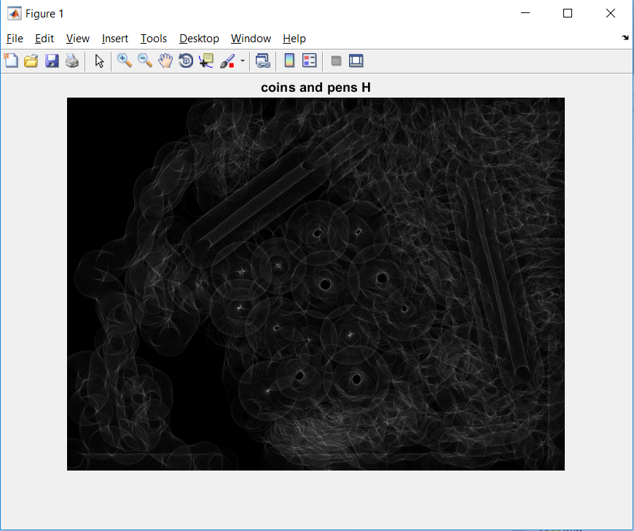

Threshold3=0.5 * max(H7(:));

NHoodSize3= (floor(size(H7) / 100.0) * 2 + 1);

peaks7 = hough_peaks(H7,10,Threshold3,NHoodSize3);

hough_circles_draw(j,peaks7, 20);

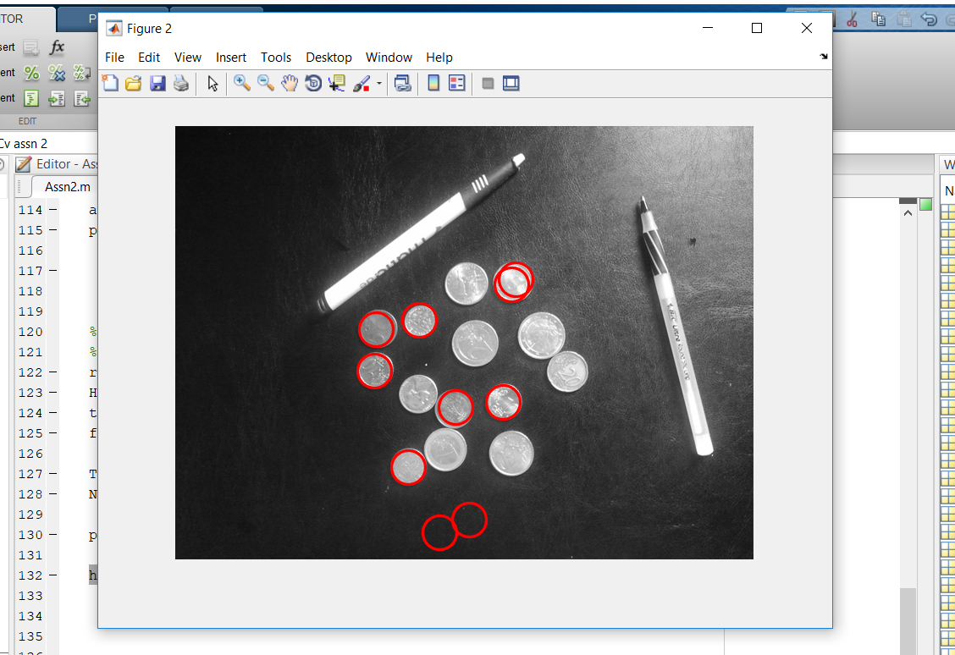

Using Code in part 2

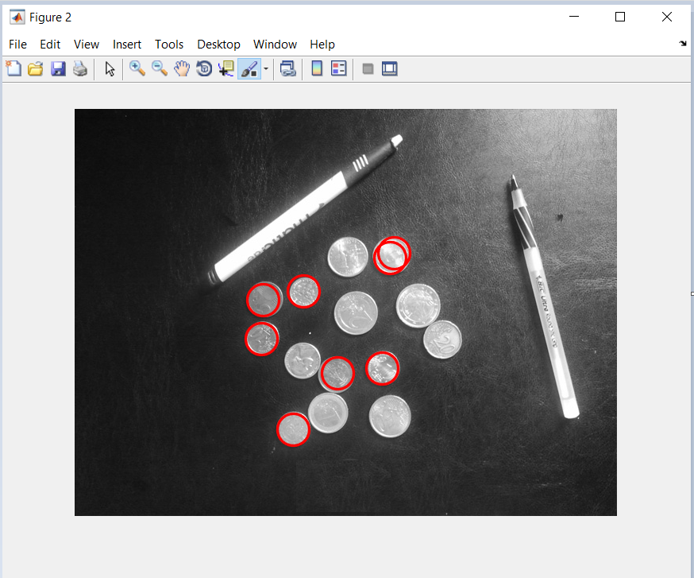

But still am having small issue. I GOT TWO ROUNDS FOR THE SINGLE COIN.